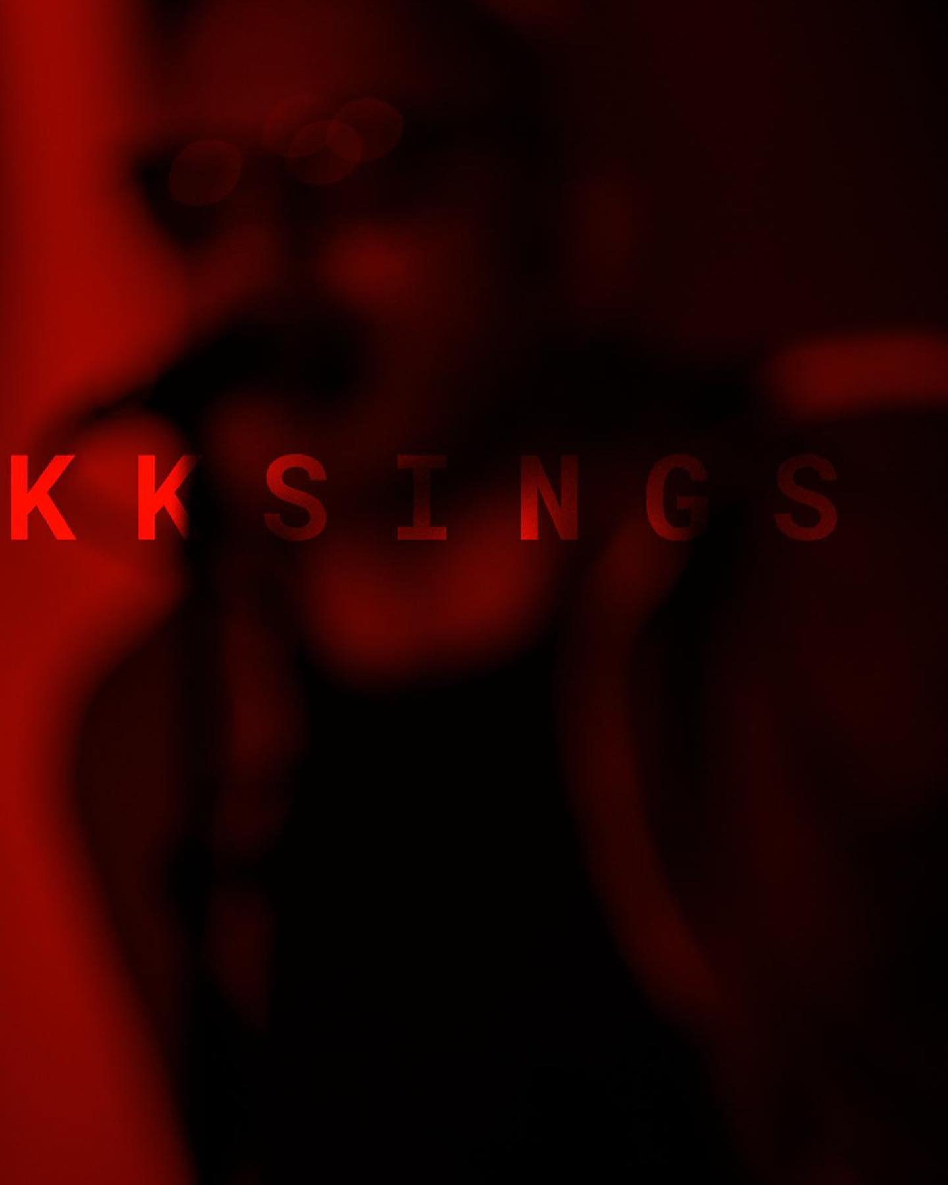

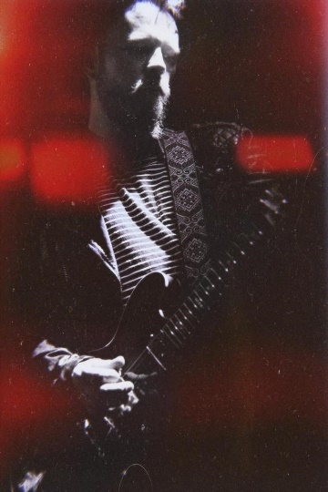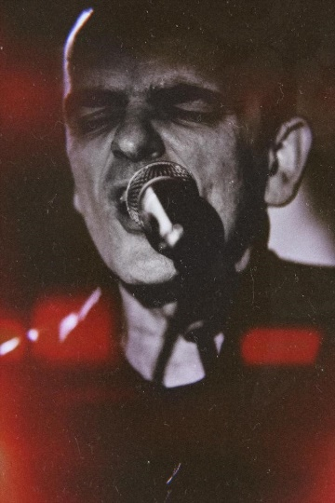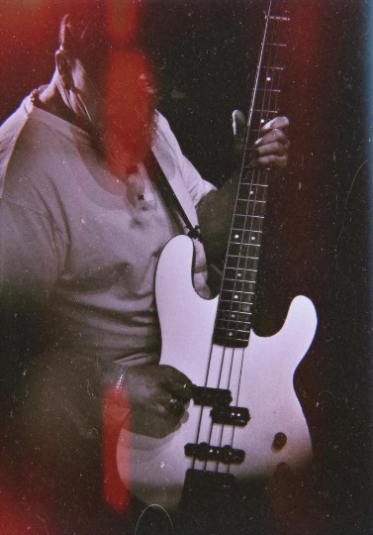

"No one puts the emptiness into music as hopefully as KKsings, and every line of text is intoxicatingly elegant," raves the review. KKsings is the band of the Frankenthal musician, songwriter, producer and founder of the indie label 'Down At The Dogs': Klaus Kummer alias KK.

A few years ago, KK made a name for himself beyond the borders of his hometown with his German-English project COLE, then rocked the Delta with the independent band ZANE. With KKsings he has once again reinvented himself.

The project and band emerged from KK's song diary on Facebook. Since 2008, he has been publishing new songs there at the exact moment they were written - recorded only with the dictation function of his mobile phone. Over the years, KKsings has found many friends around the planet.

Last but not least, producer and exceptional guitarist Stefan Kahne also became aware of the project. After a joint performance at the Capitol in Mannheim, they immediately agreed to make music together. With his two albums "Rocket Song" and "Sweet Addiction", KK is opening a whole new chapter in his musical career.

"If he came from Berlin and wasn't so modest, the national pop press would be singing his praises," wrote the Mannheimer Morgen in December 2020. "Some of the songs are quite dark, but KK never loses his footing. When he encourages us to sing along in the catchy finale, all will be well. We find him unharmed, raise our arms with the lighters, press repeat and trustingly accompany him again on his wild ride through the depths and shallows of the human soul".

Band:  
Klaus ‘KK’ Kummer // Vox, Guitar  
Stefan Kahne // Guitar, B-Vox  
Achim Degen // Guitar, B-Vox  
Hans Mappes // Bass  
Michael Germer // Drums

 [**Spotify**](https://open.spotify.com/artist/7cnzJHlXuuMzUzSODA0sWd?si=b-rAzWyNRBue-y0gp3QAVw)  [**YouTube**](https://www.youtube.com/c/KKsings)  [**Instagram**](https://www.instagram.com/kksinx/)  [**Facebook**](https://www.facebook.com/KKsings)  [**Web**](http://kksings.de/)